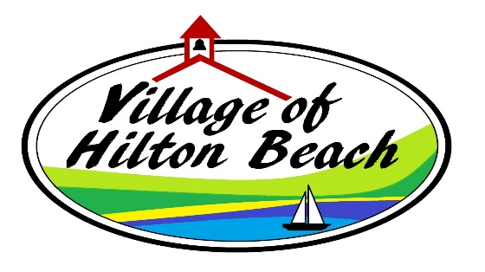
EMPLOYMENT OPPORTUNITY –MARINA – AGED 16 AND OVER
Applications will be accepted until Wednesday APRIL 23 at 4:00 p.m. for MARINA ATTENDANT/PARKS
MARINA ATTENDANT
As Marina Staff, you are the first point of contact for all visitors and as such are required to be respectful, polite and friendly. Marina staff are responsible for guiding and directing boaters into slips and assisting in securing boats to and releasing boats from their mooring. Marina staff register boaters and complete retail sales transactions. Duties also include maintenance of the marina facility and grounds. Familiarity with boating, boating regulations, and use of a VHF radio is considered an asset.
LANDSCAPING/GROUND ASSISTANT
The position will assist with maintaining the grounds around the Village of Hilton Beach and will include duties such as cutting grass, trimming, pruning, raking, weeding, and painting along with small job repairs.
Qualifications
- Excellent interpersonal and customer service skills
- Punctual and responsible, fast learner and eager to assist
- Ability to multi-task and work without supervision
- Knowledge of health and safety protocols
Please forward your resume and cover letter to Myra Eddy, Clerk-Treasurer, Village of Hilton Beach clerk@hiltonbeach.com.

All applicants are thanked for their interest, but only those selected for an interview will be contacted. The Village of Hilton Beach is an equal opportunity employer and all information collected will be used in accordance with the Municipal Freedom of Information and Protection of Privacy Act for the purposes of job selection.

