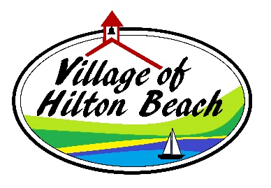
NOTICE
Budget Adoption and By-law Amendment
Pursuant to Section 290 of the Municipal Act, 2001 as amended.
Notice if hereby given that the Council of the Village of Hilton Beach intends to adopt the 2026 Municipal Budget and By-law 2026.24 being a by-law to Regulate the Maintenance and Care of Land in the Village of Hilton Beach at the regular Council Meeting on June 10th at 6:00 p.m. at the municipal office at 3100 Bower Street, Hilton Beach.
Members of the public are welcome to attend
The 2026 Budget summary and by-law are available for review at the municipal office and on the municipal website.
Note: This shall serve as Public Notice should the adoption of the 2026 budget be deferred to a future meeting
Myra Eddy
Clerk-Treasurer
Village of Hilton Beach

