VILLAGE OF HILTON BEACH
NEWSLETTER – FALL 2026

Municipal Election 2026 – 1 Mayor – 4 Councillors – Term 4 years
Nomination Forms are available at the Village Office during regular hours and must be filed at the
Village of Hilton Beach’s municipal office by 2 p.m August 21st. All completed and filed forms are public documents.

Advance Poll Date – Saturday, October 17th 10 am – 5 p.m.
Community Hall – 3050 Hilton Road
Election Date – Monday, October 26th 10 am – 8 p.m.
Community Hall – 3050 Hilton Road
Want to learn more – go online to: Ontario Municipal Councillors Guide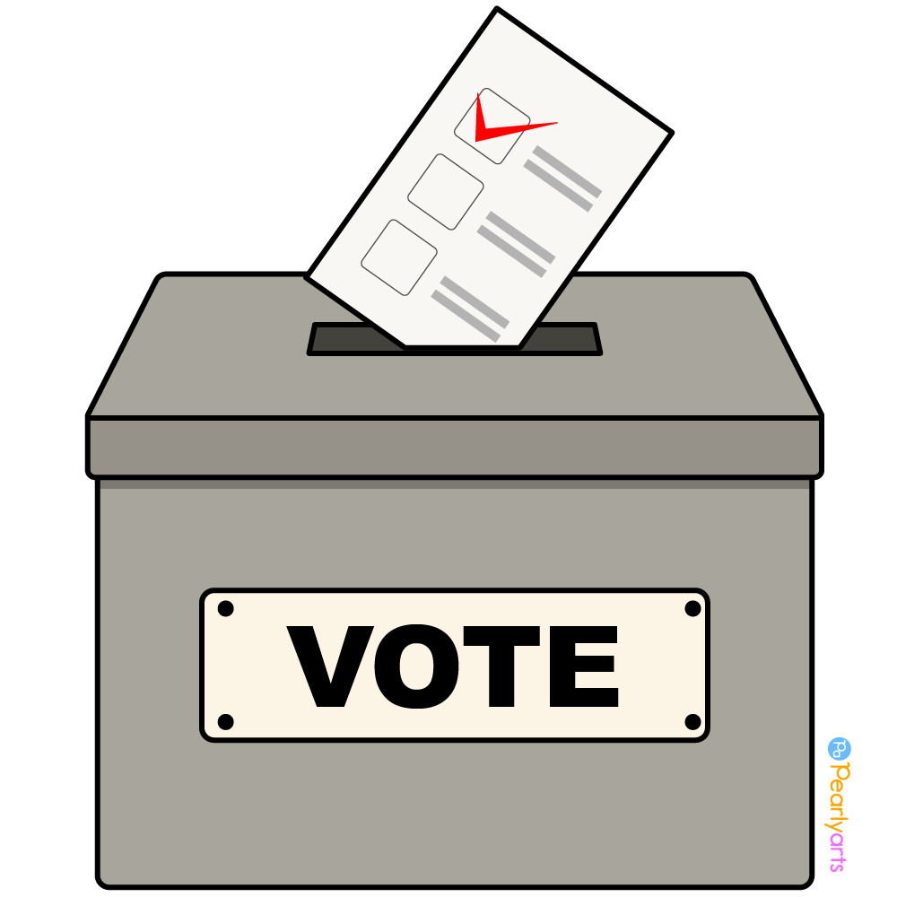

Village Council
Council meetings are held on the second Wednesday of each month in the Municipal Office
at 6 p.m. If you have an item to bring to Council, Please submit your request on the delegation form
in person or email no later than the Thursday prior to the scheduled meeting.

Office Hours:
Monday, Wednesday, Thursday and Friday – 9:30 a.m. to 4:30 p.m.
CLOSED Tuesdays
Website: www.hiltonbeach.com
Email: info@hiltonbeach.com
Phone: 705-246-2242

TAX BILLS
The Final 2026 tax bill is due Friday, August 28th. Taxes can be paid by cash, cheque or online banking. If you want to pay by EFT, please let the office know.

2027 Tax Bills
Interim 2027 Tax bill will be due Friday, February 26th
Final 2027 Tax bill will be due Friday, August 27th

LANDFILL
Starting August 1st the Landfill will no longer sell Landfill tickets or have cash on site.

Punch Tickets can be pre-purchased at:
Village of Hilton Beach Municipal Office
Township of Hilton Municipal Office
Hilton Beach General Store
Island Timber Mart
(thank you to the businesses who are supporting
us by selling the tickets)

Landfill Hours
Saturday – 10 am – 3 p.m.
Sunday -12 noon to 4 p.m.
Additional Hours from May 15 to September 15
Wednesday – 12 noon to 5 p.m.
Mondays of long weekends – 12 noon to 4 p.m.

Curbside Garbage Pick up
January – May : Last Saturday of the month
June: Second and last Saturday of the month
July and August: Every Saturday
September: Second and last Saturday of the month
October to December: Last Saturday of the month

Want to know what you can recycle at the bins at the Landfill? Go online and type in Circular Materials residents Hilton Beach or www.circularmaterials.ca/resident-communities/hilton-beach/
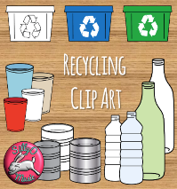

Construction
Replacement of the ramp at the Waterfront Centre is still a go! Please be patient and careful around the construction to keep everyone safe. We apologize for this inconvenience. You are welcome to access the post office and businesses by the Village Office during open hours and if you require assistance after hours call Councillor Brian Delvecchio at 705-971-0448.

Roads
Beemish Construction will be in the area shortly to spray Fog Sealant on the following roads:
Ringham, Boundary, East St., Canoe Point, Park St., Bower East and West. Please be careful and mindful around the equipment.

Dogs
All dogs within the Village must be registered and licensed annually. Owners are to visit the municipal office to obtain one. There are fines for failing to register your pet. $30.00 for each of the following: failure to license, permit a dog to run at large, failure to remove dog excrement. Owners must ensure that there is no persistent barking. No dogs permitted to run at large and must in be in control at all times, including not being off-leash outside the owner’s property while taken for walks. Please – stoop and scoop and properly dispose of the excrement. Do not flush bags as it is hard and can cause damage to our sewer treatment plant.

Events
Watch for upcoming Village Events on our website and facebook. The annual Holly Jolly Craft show will be this November 14th. Want to be a vendor? Call 705-246-2242 and talk to Paula.

