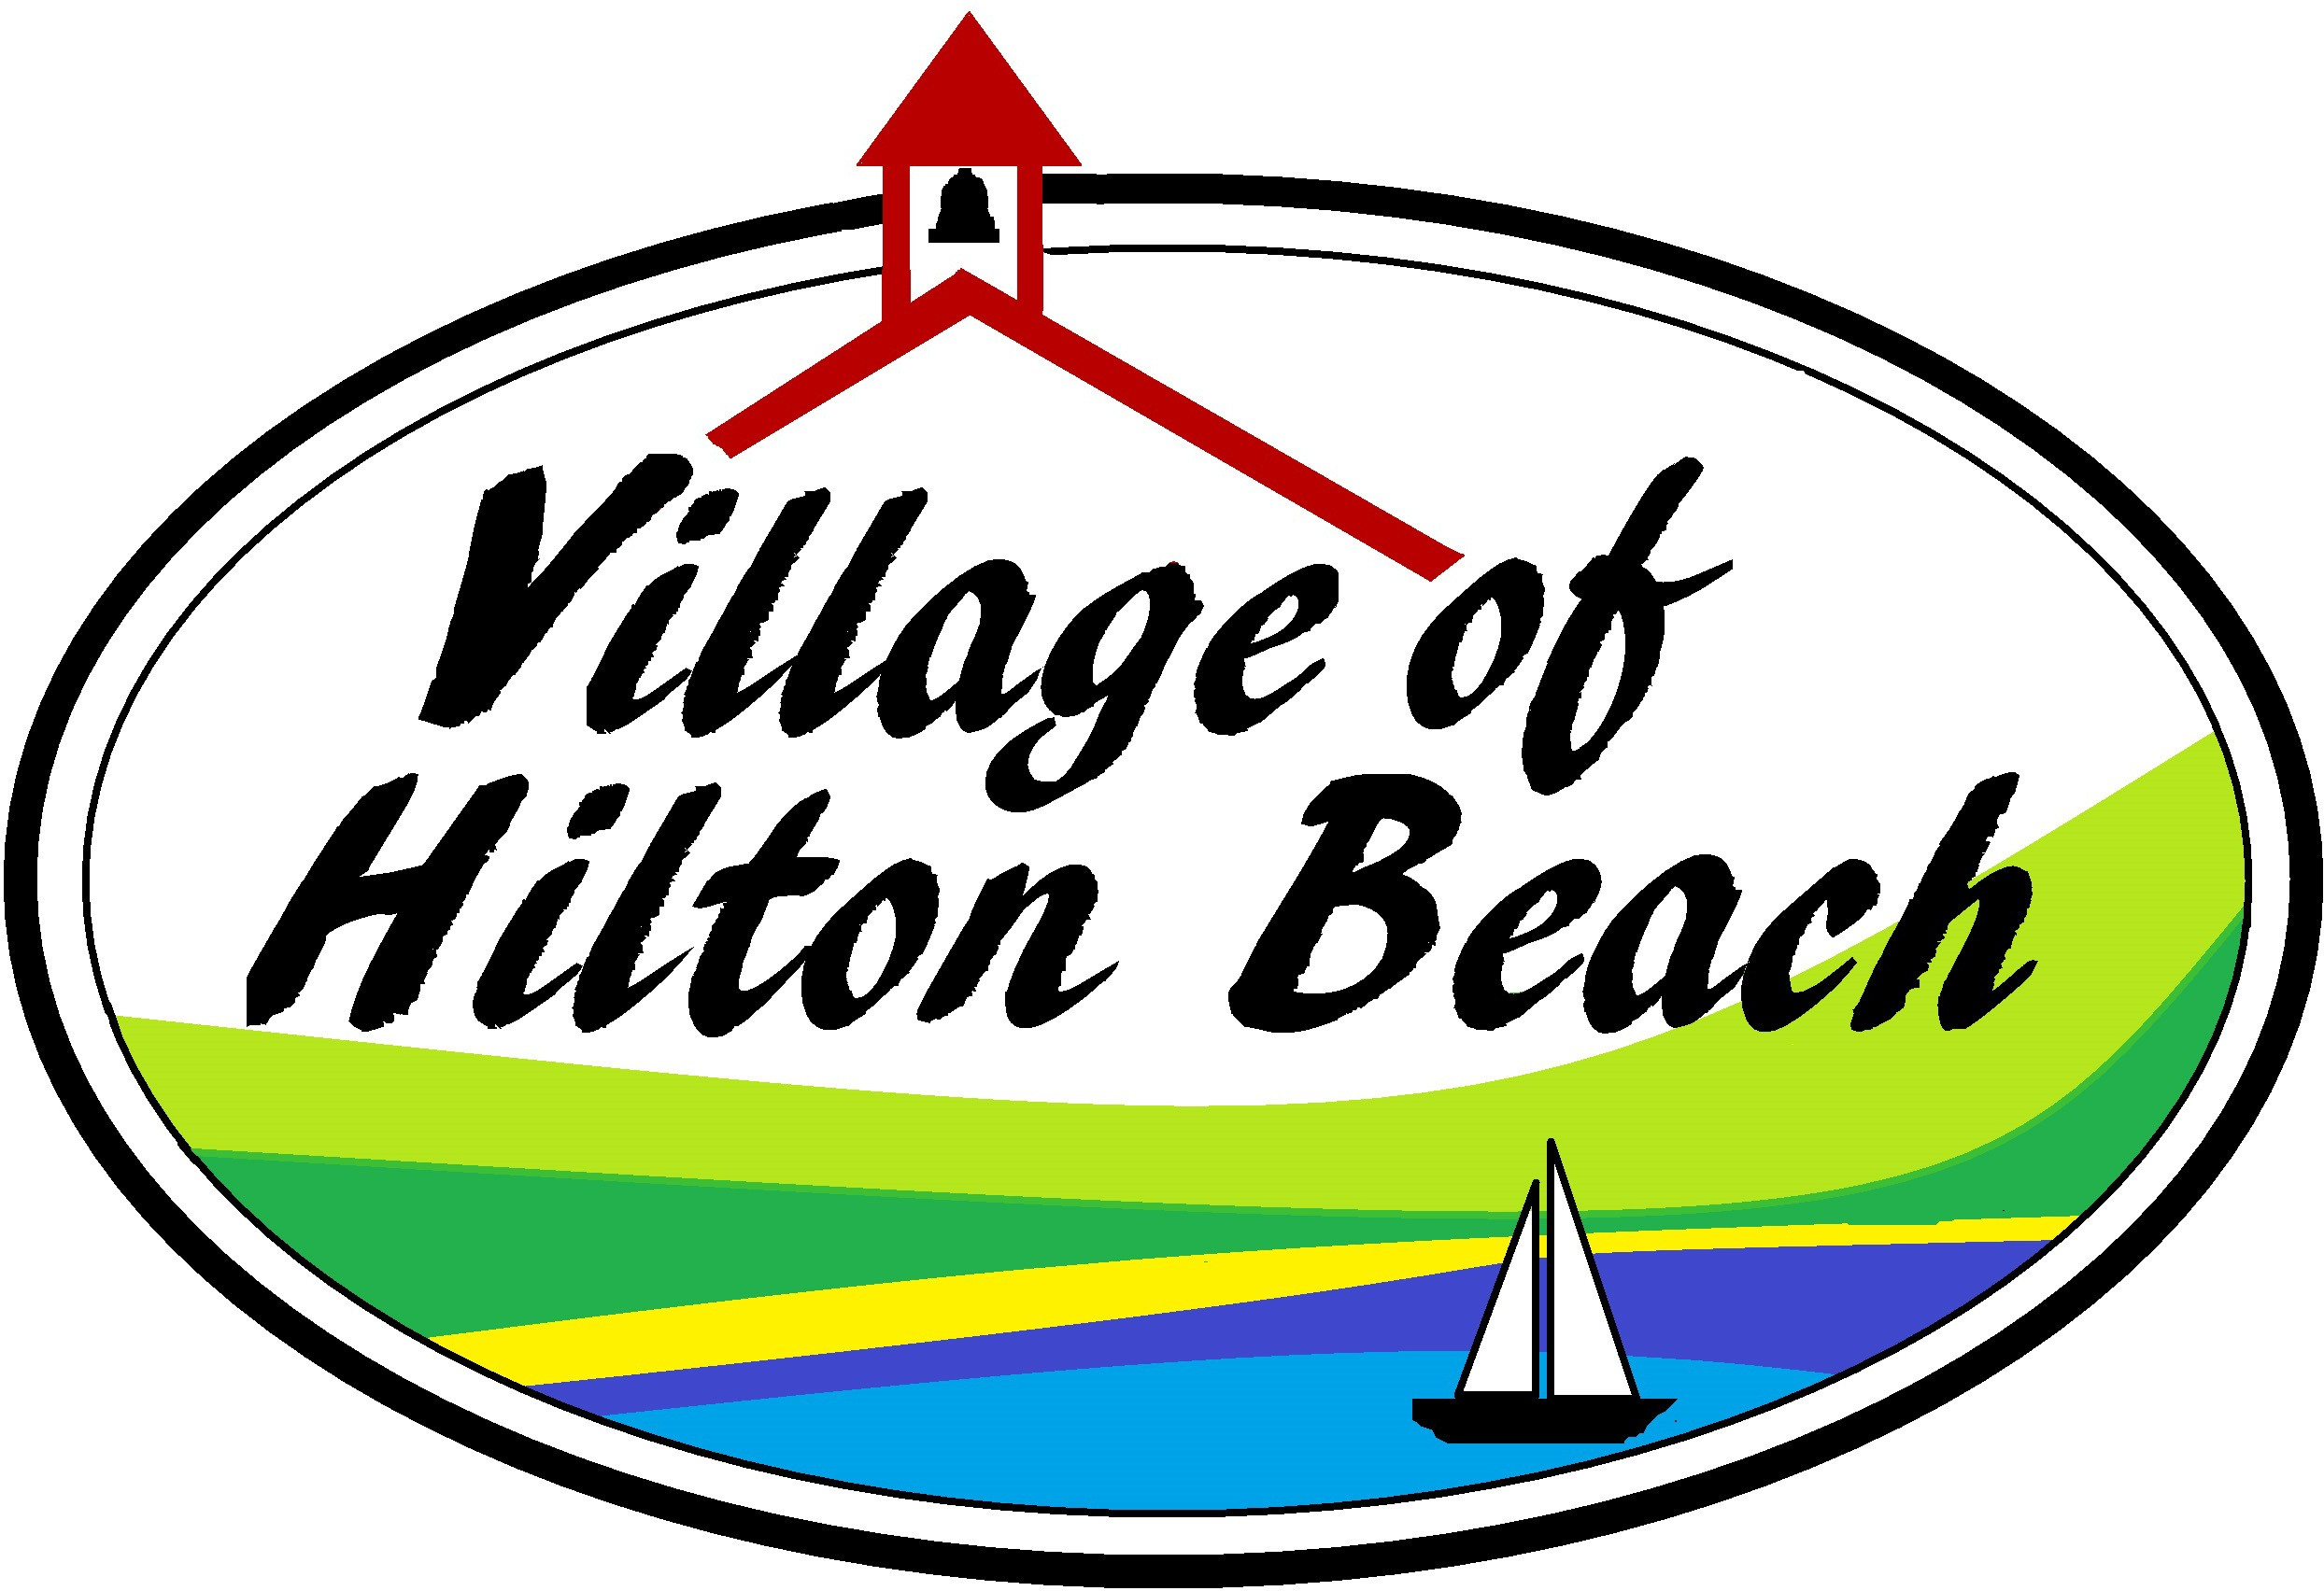
Form LC03
The Incorporated Village of Hilton Beach

UNOFFICIAL LIST OF CANDIDATES
CANDIDATE NAME | POSITION | QUALIFYING ADDRESS | EMAIL
Robert Hope | Mayor | 3092 6th Street | sedanbridgebob@gmail.com

