
Form EL20

DECLARATION OF ACCLAMATION TO OFFICE
Municipal Elections Act, 1996, s. 37(1)

I hereby declare the certified candidates listed below to be acclaimed to the office that follows their respective names pursuant to Section 37 of the Municipal Elections Act, 1996:

Name of Certified Candidate | Office
Robert Thomas Hope | Mayor
Brian Anthony Delvecchio | Councillor
Sally Mildred Cohen | Councillor
Patrick Rathwell | Councillor
Donna Morin | Councillor

Dated this 24 day of August , 2026.

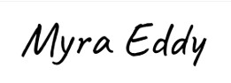
Municipal Clerk
Incorporated Village of Hilton Beach

