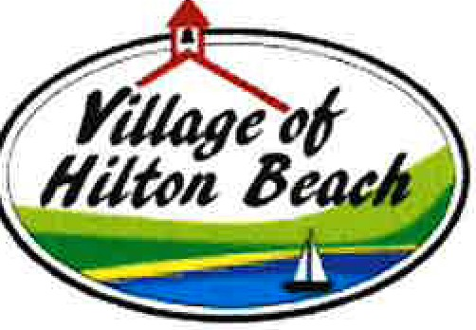

Form LC03

The Incorporated Village of Hilton Beach

UNOFFICIAL LIST OF CANDIDATES

CANDIDATE NAME | POSITION | QUALIFYING ADDRESS | EMAIL
Robert Hope | Mayor | 3092 6th Street | sedanbridgebob@gmai!.com
Brian Anthony Delvecchio | Councillor | 3100 Hilton Road | briand2009@hotmail.com
Patrick Rathwell | Councillor | 3010 Canoe Point Road

